**Advancement Via Individual Determination**

**Welcome to Mrs. Vacianna’s AVID Class!!**

You have been chosen by AVID, and you have chosen AVID! The AVID elective is designed to equip, support, and inspire you as you pursue your college dream. By joining AVID, you have become a member of a worldwide family with more than 450,000 members. AVID is a college readiness system that started in San Diego more than 30 years ago. ***The mission of AVID is to "close the achievement gap by preparing all students for college readiness and success in a global society."***

**Course Description**

The AVID class has two goals: the first, to prepare students for college and university entrance requirements, and the second, to ready students for the rigors of college and university work. In other words, we want to help you jump through the hoops necessary for college entrance and help you to become the kind of student who will excel once you get there.

This course offers a challenging curriculum that exposes students to college-level reading and writing assignments in an attempt to develop students' academic skills. In addition to academic skill development, you will learn about the college/university system, conduct research projects, and interact with college tutors.

It is important to note that good grades, a competitive GPA, and maintaining an organized binder is only part of the AVID commitment; AVID students are also encouraged to get involved in school leadership, athletics, performing arts, clubs, and other extra-curricular activities. Getting involved in the school and local community will shape you into responsible participants and leaders in a democratic society--another goal of the AVID class.

***During this school year you will grow in your...***

* Ability to read, comprehend, discuss, and write about challenging texts.
* Ability to organize and plan for success.
* Use of writing as a tool for learning.
* Ability to engage in structured discussions (Socratic Seminar, Philosophical Chairs, etc.)

moreover, to make positive contributions to those discussions.

* Ability to use the AVID Focused Note-taking system (i.e. Cornell Notes) as a tool for

learning

* Knowledge of the college/university system and the road you must travel to be "college ready."
* Ability to ask questions to clarify points of confusion and collaborate with classmates and

tutors to give and receive help using the AVID Tutorial model.

•Work collaboratively on assignments and projects.

|  |  |  |  |  |
| --- | --- | --- | --- | --- |
|  | **A Typical** | **Week In** | **AVID** |  |
| **Monday** | **Tuesday** | **Wednesday** | **Thursday** | **Friday** |
| Tutorials | Projects, AVID curriculum, academic skill-building, critical reading and writing | Projects, AVID curriculum, academic skill-building, critical reading and writing | Tutorials | Team-building,  Guest Speakers, Structured Discussions,  College Research |

There are certain activities you should expect to participate in consistently throughout the year. They are designed to support you in your classes and help you achieve success. They are:

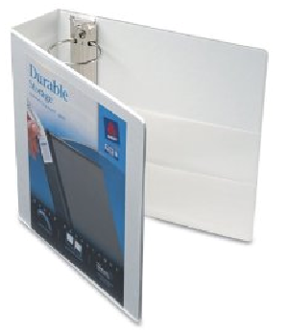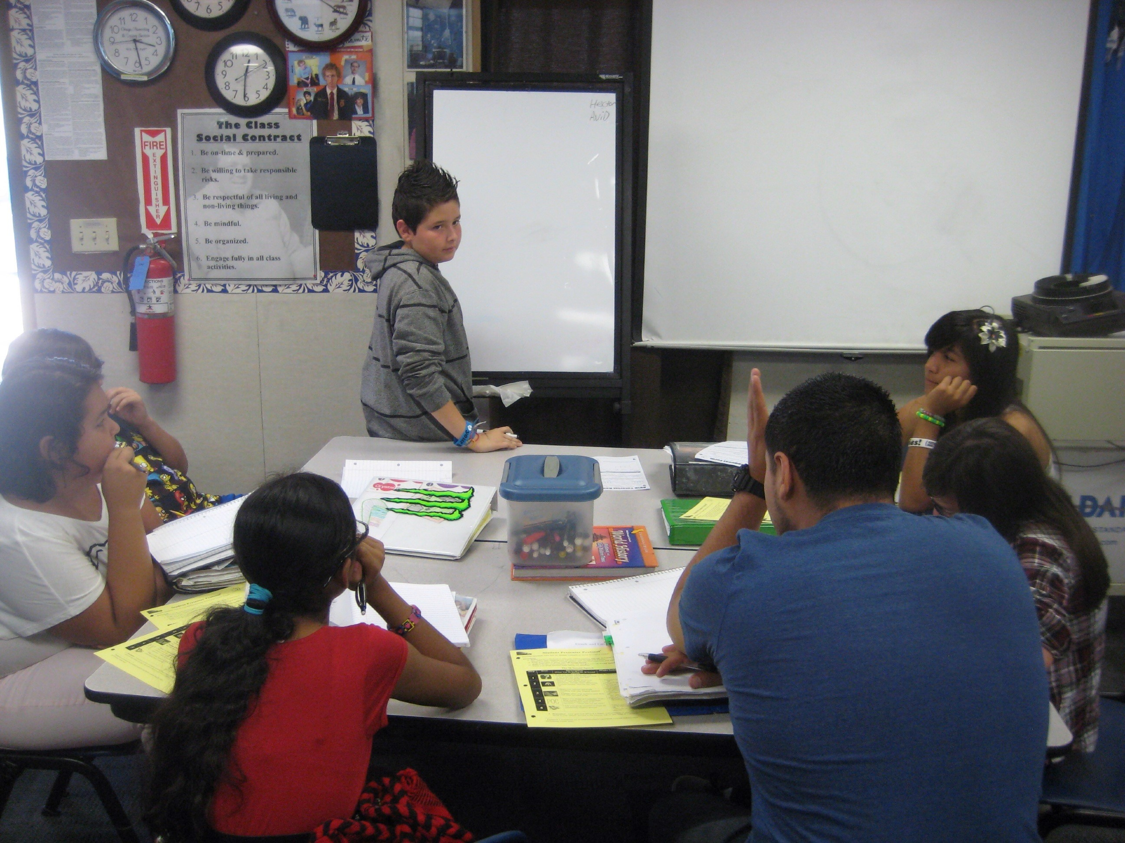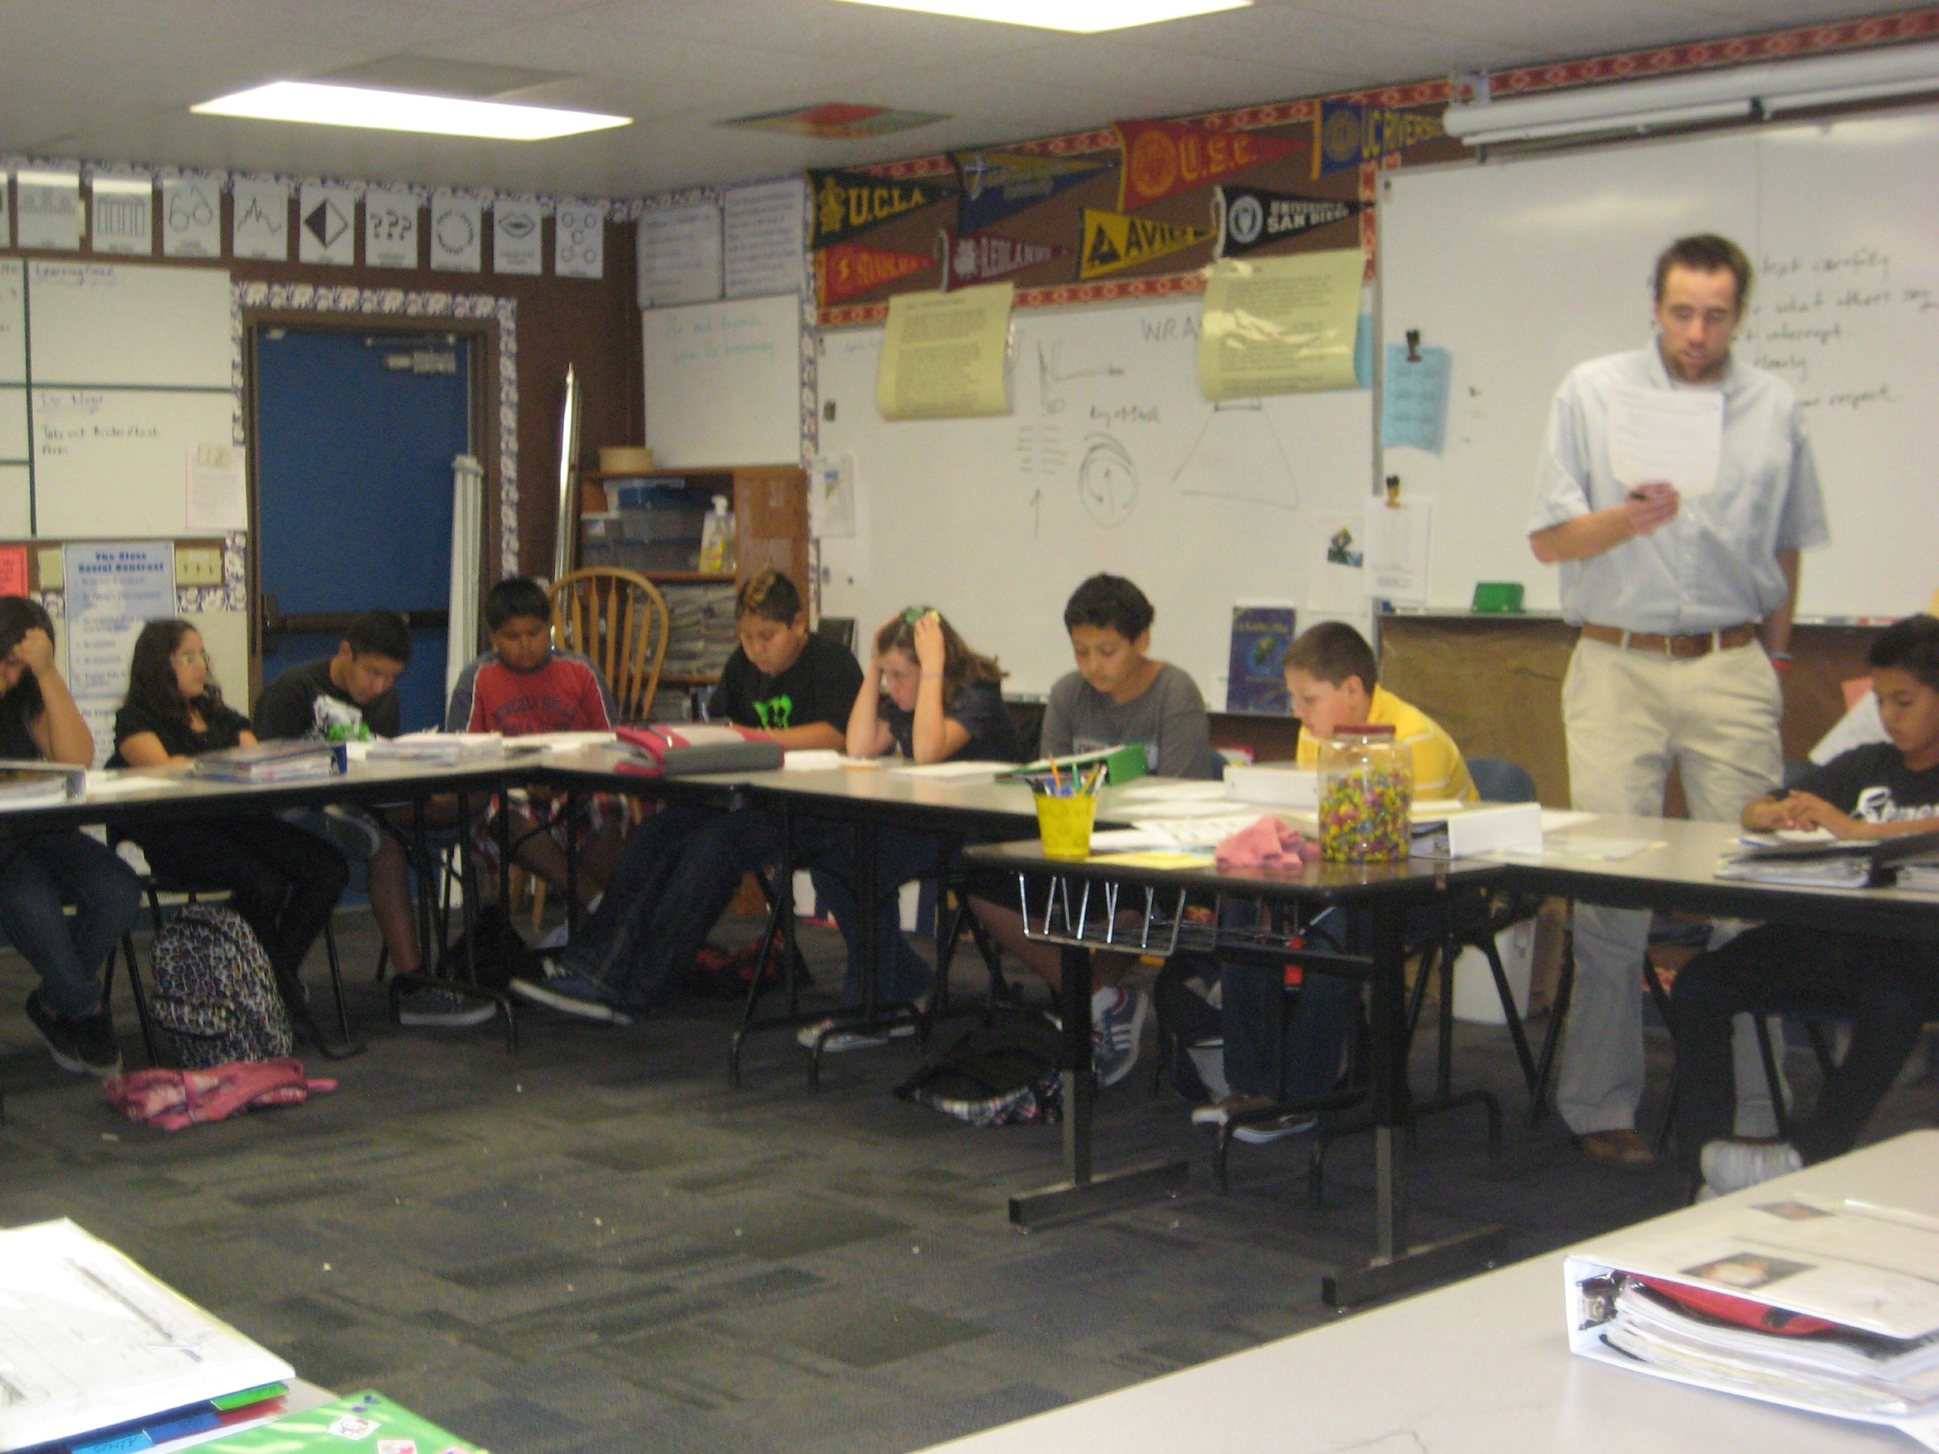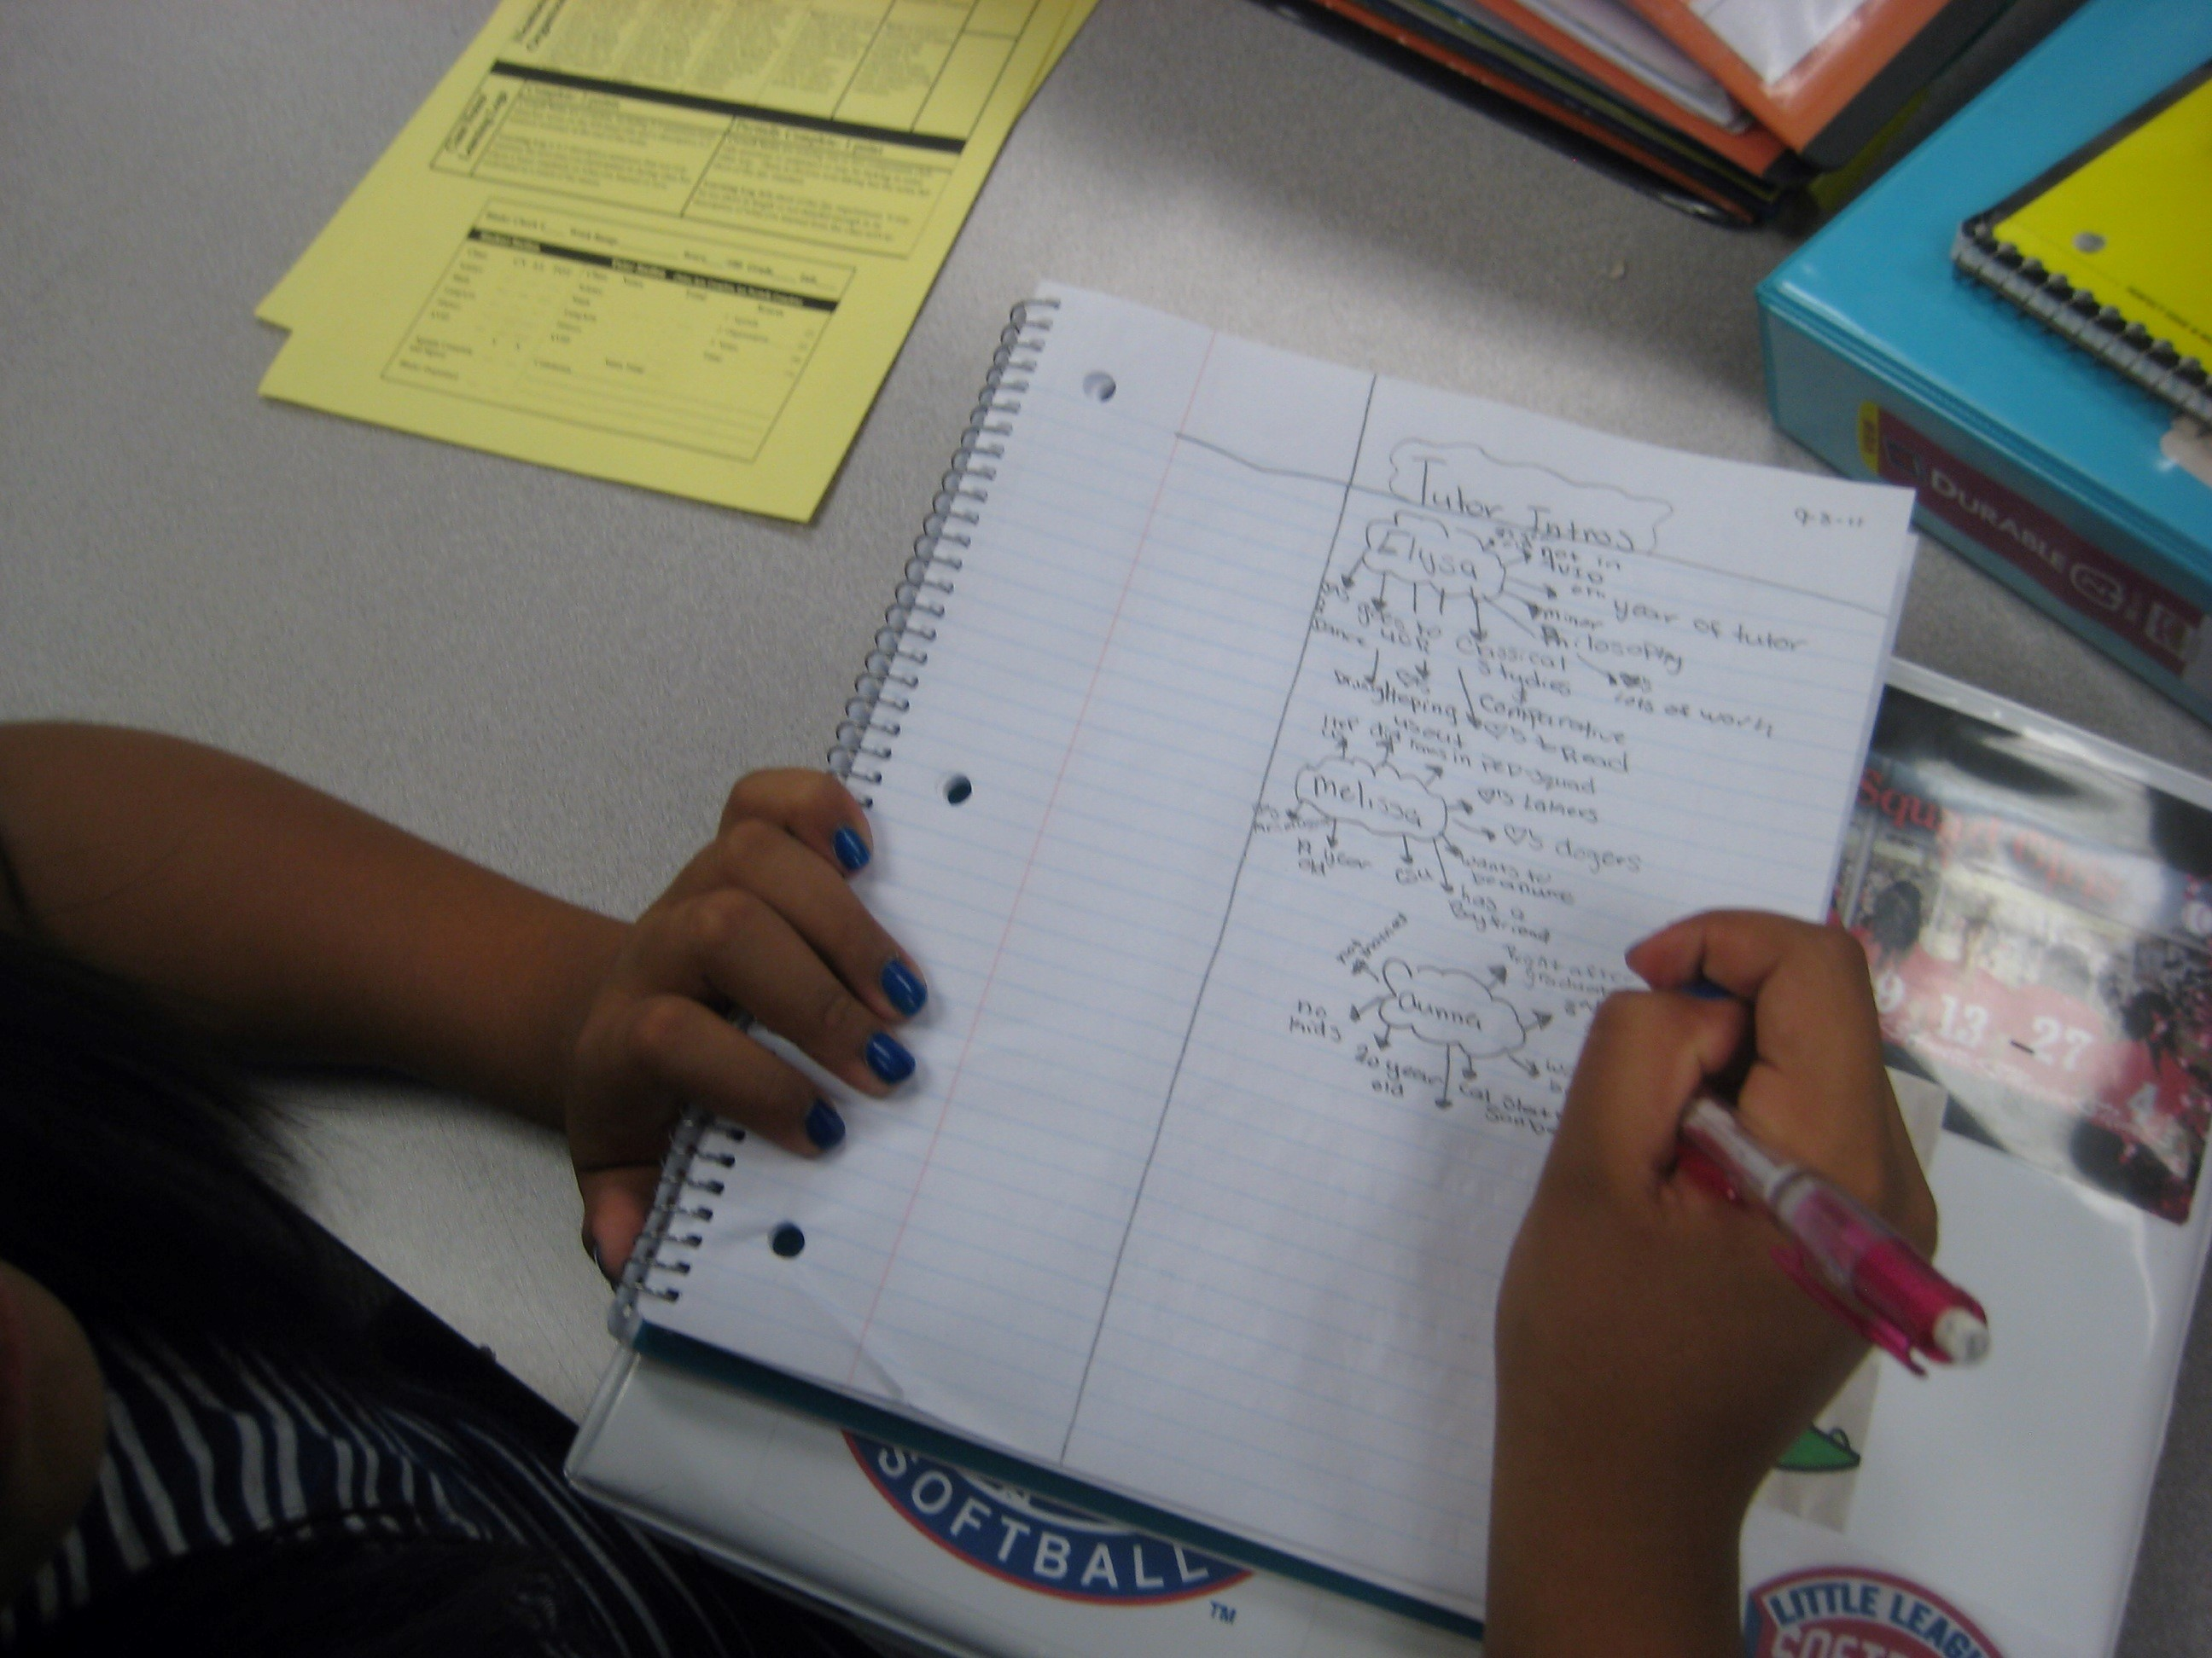

1. **Tutorials --** Tutorials are a collaborative group activity where you will follow a process to give and receive help for your core content classes. Expect to participate in Tutorials every Monday and Thursday throughout the year. College tutors will be available to support your learning throughout the school year.
2. **Binder Checks --** Every week your binder will be graded. If you do not get your binder graded on the day of binder checks, it is your responsibility to have it graded on the next day.
3. **Socratic Seminar/Structured Discussions --** Structured discussions such as Socratic Seminar and Philosophical Chairs will be utilized throughout the year to help you learn to interact with texts you are reading and the ideas they bring to the surface. You will learn to dig in to an author's meaning, listen for understanding to your classmates, and express your own ideas with clarity.
4. **Cornell Notes/Focused Note-Taking (Multiple Formats) --** You will learn to take and use Cornell Notes as a tool for recording and interacting with various texts and lecture material.
5. **Critical Reading of Texts --** You will develop the ability to read, discuss, and write about challenging texts in order to prepare you for the rigors of academic environments. AVID students will learn to mark texts, account for key terms and claims made by authors in expository texts, and use "Pausing to Connect" and "Writing in the Margins" as tools for unlocking the meaning of challenging texts.



**Course Policies and** **Expectations**!

**Participation**

Participation is key to success. An active participant shares his or her ideas with their partner(s), group, and/or class, completes assignments on time, works collaboratively in groups, and contributes to the class as a whole. You should also participate in school activities such as clubs or after school sports. A student who gets involved in his or her school experiences greater success in academic classes, learns valuable life lessons, and typically develops great friendships.

**Organization**

Students who are organized turn in assignments more regularly, forget to do things less often, are more successful, and live with much less stress than disorganized students. Middle School can be very stressful at times...do yourself a favor by being organized!

**Class work**

You will be expected to turn in class work on time. Work that is not completed in class must be completed at home and brought to the next class meeting. There are penalties for turning in late work, so get in the habit of completing assignments on time.

**Homework**

You will have homework throughout the week. Typically, homework will consist of preparing for Tutorials, organizing your binder, and refining/studying your Cornel Notes. Occasionally, assignments started but not finished in class will be given as homework. As the following day's work will usually depend on/build on your completion of the homework assigned, it is essential that you complete all assigned homework.

**What Do I Do When I'm Absent?**

It is your responsibility to find what we did in class on days you miss. I recommend having a "buddy" in class that you can call to get any notes or explanation you need. Assignment due dates are extended as many days as you were absent (ex. miss 2 days, due-date extended two days).

**Revising and Resubmitting Work**!

I place a high value on students revising and resubmitting assignments until they have demonstrated their best work. You have one week from the time you receive your graded work and tests back to revise and resubmit for a chance to earn a higher score. Most assignments can be revised and resubmitted; if an assignment cannot be revised, I will tell you. Fixing and turning in work again does not guarantee you will earn more points -- you must demonstrate greater mastery of the material to earn more points. The main assignment students find themselves needing to fix are binder checks. If you earn a grade lower than a C on a binder check, you will be required to come after school to fix the issues and get it re-graded.

**Class Guidelines and Procedures**

**Here is a brief description of what I expect from you in class.** Following rules is like living in a lawful society. We follow laws in society in order to maintain an orderly world, one that is safe and secure. We may not always agree with the rules or laws, but we must do our best to uphold them whenever possible. The same is true for this class. There are rules for this class that we all must follow. You do not have to agree with the rules, but you must adhere to them. In this class, you are expected to follow all school-wide rules. There are also some guidelines that are specific to this class.

**1.** During discussions, respect other student's comments, opinions, and ideas. Listen to what others say and do not interrupt.

**2.** Do not hold your hand in the air while another student is speaking/responding. If you are not called on, put your hand down, look at and listen to the person who is speaking, then put your hand in the air when they have finished.

**3.** When we read together in class, you must follow along. If I call on you to read, you must know exactly where we are and begin reading immediately.

*Thank You.*

**4.** Make eye contact. When someone is speaking, keep your eyes on him or her. If someone makes a comment, turn and face them.

**5.** You will make every effort to be as organized as possible.

**6.** Speak at appropriate times in an appropriate way.

**7.** Be prepared. Come to class each day with your binder, student agenda, and all other required materials.

**8.** Be creative by thinking of new ways to solve problems and demonstrate learning.

**9.** Accept that you are going to make mistakes. Learn from them!

**10.** The first thing you will do when you enter class is copy the day's objective/essential question in your student agenda. Then complete your vocabulary warmup activity in the appropriate place. I should not have to ask you to write your agenda or complete your warm-up...it should become automatic.

**11.** Get used to working with lots of different people. The seating chart changes a lot in this class and there are many different ways I group students to work on assignments. If you are having a problem with another student in class, please talk to me in private as soon as possible.

**12.** Take pride in the work you do! The work you do is a direct reflection of who you are. It shows me what you know and know how to do. All work must be complete and legible. Assignments that are crumbled or destroyed in any way will not receive credit.

**13.** Cheating will not be tolerated. If you copy someone's work or ideas, you will receive a zero

for that, assignment and I will call your parents/guardians. The same applies if you knowingly allow someone to copy from your work.

|  |  |  |
| --- | --- | --- |
| **Class Rules**  **(Cliff's Notes Version)**   1. Be on time and prepared. 2. Be respectful 3. Be willing to take responsible risks. 4. Be mindful. 5. Be organized. 6. Engage fully in all class activities. | **Consequences Include**  *Verbal Warning  *Detention and/or Parent Contact  *Referral to Office | *We expect excellence from our AVID students. It is a privilege to be in AVID at DCMS, not a right. We are working with you to help you achieve your college dream, investing a lot of time, money, and energy into helping you be successful now and well prepared for the future. As your AVID teacher, I am concerned with your achievement in ALL your classes. If you are failing or are a behavior problem, I will organize a parent conference to discuss ways of getting you back on track. I may also require you to attend after school tutoring until your grades improve.*  ***Consistently poor behavior and/or academic performance will result in a parent meeting and possible removal from AVID.*** |

**Contact Me:**

My conference period this year is during 3rd and 5th period

Briquitta Vacianna

[briquitta.vacianna@fortbendisd.com](mailto:briquitta.vacianna@fortbendisd.com)

281-634-2057